- Login Related Commands:-
- Ssh: Connects securely to a remote Linux server.
- Real use case:
- Basic login: ssh user@server_ip
- Example: ssh vagrant@192.168.56.101
- Used for:
- Managing remote servers
- Cloud VM access
- DevOps deployments
- Risk: If password authentication is enabled and weak passwords are used, server can be compromised.

🔹 SSH WITH PORT
1️⃣ Command: ssh -p port user@server_ip
2️⃣ What it does: Connects to SSH running on a custom port.
3️⃣ Real use case
ssh -p 2222 vagrant@127.0.0.1
(Common in Vagrant setups)
4️⃣ Risk
⚠️ Incorrect port → connection fails.

🔹 SSH USING PRIVATE KEY
1️⃣ Command: ssh -i private_key user@server_ip
2️⃣ What it does
Logs in using SSH key authentication.
3️⃣ Real use case
ssh -i mykey.pem ec2-user@3.110.10.25
Used in:
- AWS EC2
- Production servers
- Secure environments
4️⃣ Risk
⚠️ If private key is leaked, attacker gets server access.

🔹 EXIT SSH
1️⃣ Command: exit
2️⃣ What it does: Logs out of SSH session.
3️⃣ Real use case: exit
- ssh into terminal:
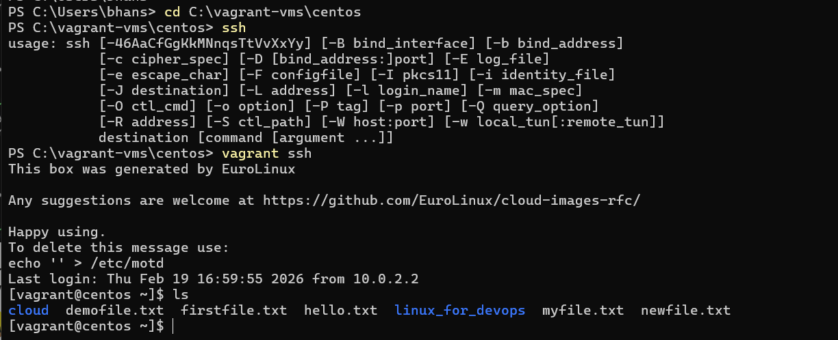
- df: Shows disk space usage of file systems.
- Displays:
- Total disk space
- Used space
- Available space
- Usage percentage
⚠️ Output is shown in blocks (1K blocks) by default, which is harder to read.
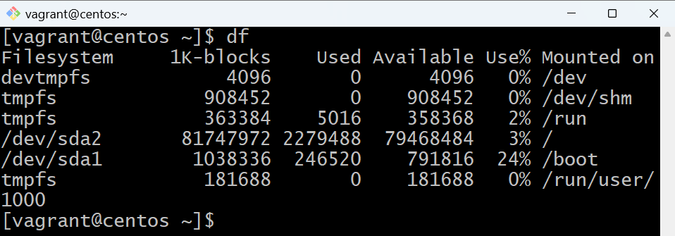

- df -h: Shows disk space usage in human-readable format.
- Real use case:
- Displays sizes in:
KB
MB
GB
- Much easier to understand.
